**Calculator Free**

**Non-Linear Functions**

Time: 45 minutes

Total Marks: 45

Your Score: / 45



**Question One: [2, 2, 2, 2 = 8 marks]**

    

   

From the above list of functions and relations, state all those:

1. representing a cubic function.
2. representing polynomial functions.
3. representing reciprocal functions.
4. whose graphs have domains that do not exist for all real values.

**Question Two: [1, 5, 2 = 8 marks]**

1. Show that  is a factor of 
2. Hence factorise and state the other two factors.
3. Using your results from (a) and (b) determine the roots of the function .

**Question Three: [2, 3, 1, 1 = 7 marks]**

1. Represent  in the form 
2. Represent in the form 
3. State the degree of the polynomial given in part (b).
4. State the coefficient of the *x* term in part (a).

**Question Four: [2, 2 = 4 marks]**

1. Sketch the graph of  on the axes below.

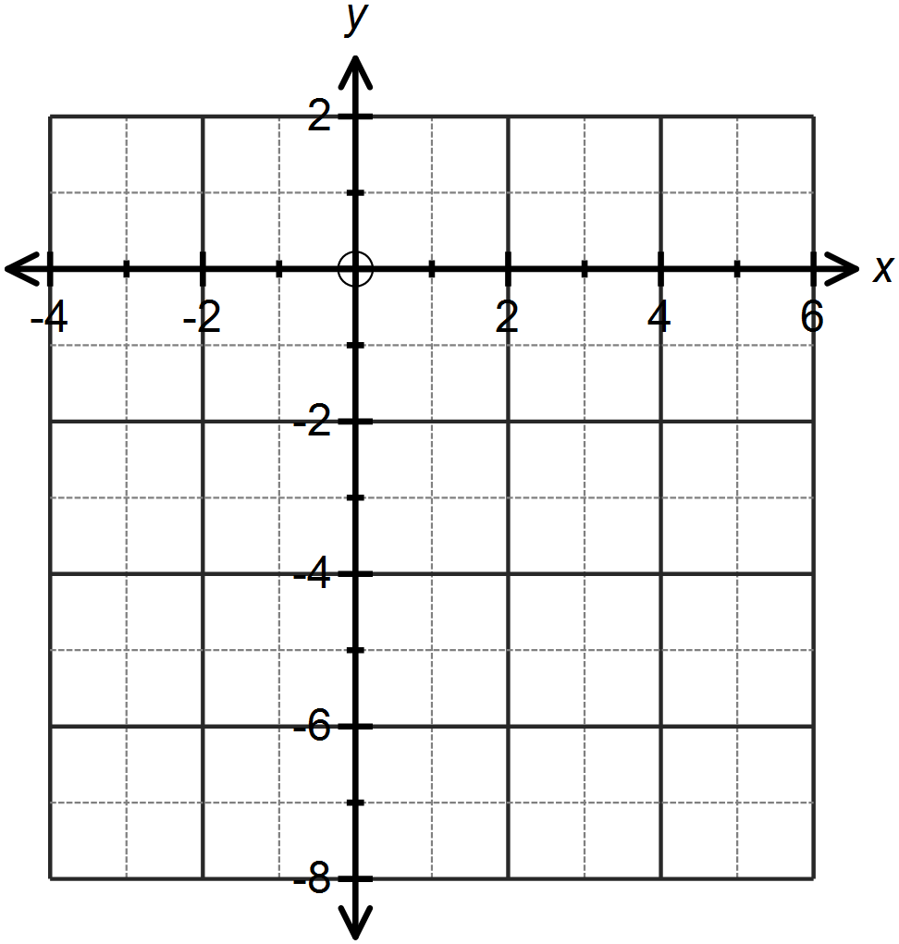

1. Explain, using the vertical line test, why your graph does not represent a function.

**Question Five: [2, 2, 2, 2 = 8 marks ]**

1. Sketch the function on the axes below.

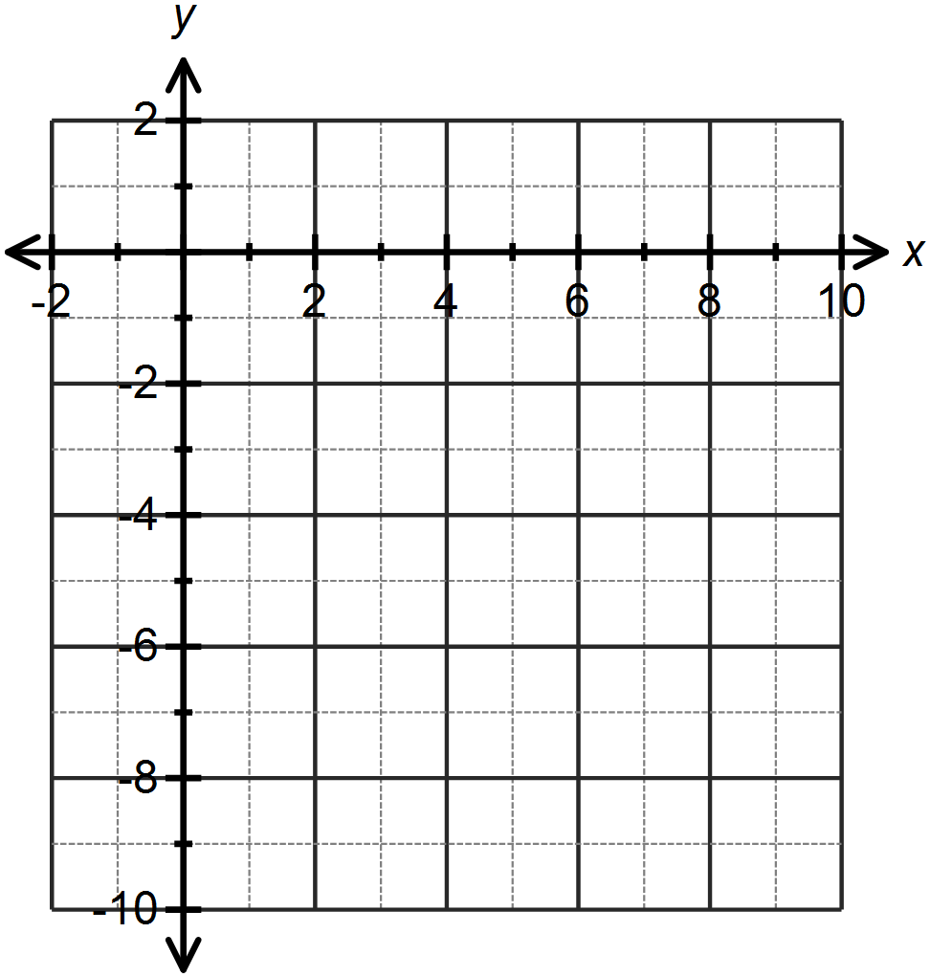

1. Sketch the function on the set of axes above.
2. Write an equation which represents the combined relationship of the two graphs drawn.
3. Does your equation in part (c) represent a function? Explain your answer.

**Question Six: [2, 8 = 10 marks]**

1. Consider the function .

Over what domain would this function represent the following context: The number of hours required to lay bricks with *x* bricklayers.

1. Consider the function .

Determine:

1. The equation of the horizontal asymptote.
2. The equation of the vertical asymptote.
3. The coordinates of the *x* and *y* intercepts.
4. The behaviour of *y* as 
5. The equation, in terms of *x*, of the function 

**SOLUTIONS**

**Calculator Free**

**Non-Linear Functions**

Time: 45 minutes

Total Marks: 45

Your Score: / 45



**Question One: [2, 2, 2, 2 = 8 marks]**

    

   

From the above list of functions and relations, state all those:

1. representing a cubic function.



1. representing polynomial functions.



1. representing reciprocal functions.



1. whose graphs have domains that do not exist for all real values.



**Question Two: [1, 5, 2 = 8 marks]**

1. Show that  is a factor of 



1. Hence factorise and state the other two factors.



1. Using your results from (a) and (b) determine the roots of the function .



**Question Three: [2, 3, 1, 1 = 7 marks]**

1. Represent  in the form 



1. Represent in the form 



1. State the degree of the polynomial given in part (b).



1. State the coefficient of the *x* term in part (a).



**Question Four: [2, 2 = 4 marks]**

1. Sketch the graph of  on the axes below.

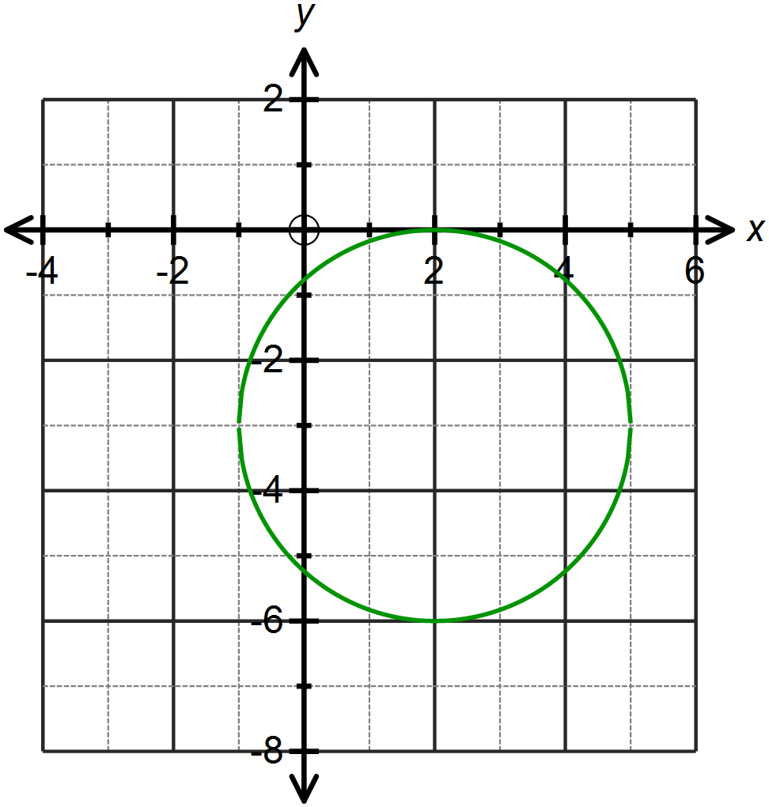



1. Explain, using the vertical line test, why your graph does not represent a function.

On the interval -1 < *x <* 5, a vertical line through the graph shows that for every *x* value there are two *y* values and thus this is a 1 – to – many relationship and hence not a function.

**Question Five: [2, 2, 2, 2 = 8 marks ]**

1. Sketch the function on the axes below.

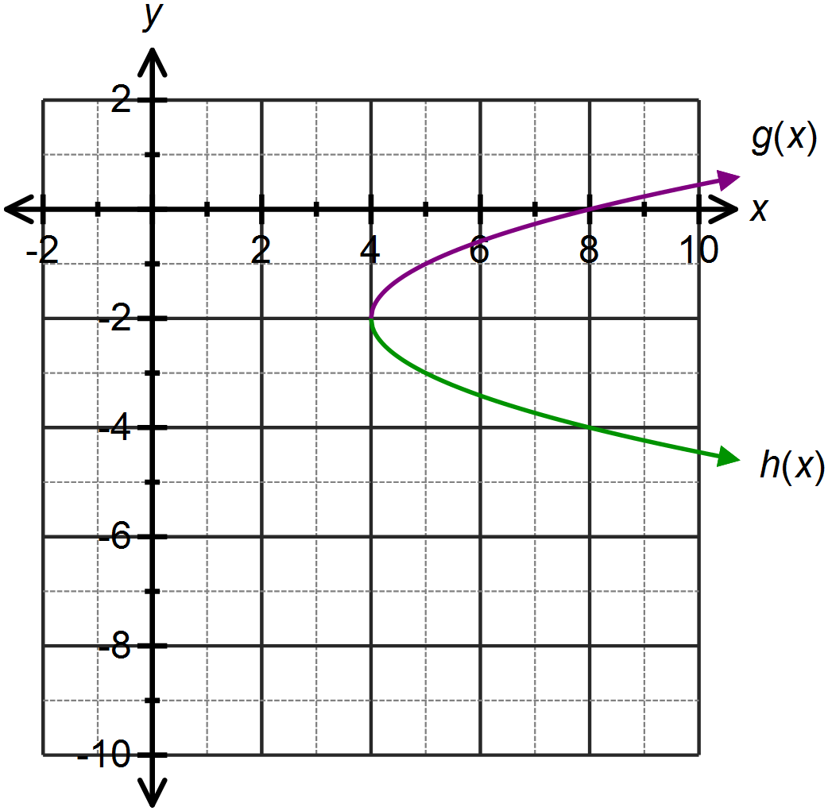







1. Sketch the function on the set of axes above.
2. Write an equation which represents the combined relationship of the two graphs drawn.





1. Does your equation in part (c) represent a function? Explain your answer.

No. The graph of this relationship, as shown above, fails the vertical line test and has more than one *y* value for each *x* value.

**Question Six: [2, 8 = 10 marks]**

1. Consider the function .

Over what domain would this function represent the following context: The number of hours required to lay bricks with *x* bricklayers.



1. Consider the function .

Determine:

1. The equation of the horizontal asymptote.



1. The equation of the vertical asymptote.



1. The coordinates of the *x* and *y* intercepts.



1. The behaviour of *y* as 



1. The equation, in terms of *x*, of the function 

